Acronyms for balanced cables
In ISO/IEC 11801:2002, the following designation can be found in Annex E. Since this Annex is informative, it means that manufacturers do not have to follow it for compliance.
xx/xxx
| | |_ balanced element __ TP
| |__ element screen ____ U = unscreened
| |__F = foil screened
|
|__ overall screen _____ F = foil screened
|__ S = braid screen
|__ SF = braid and foil screen
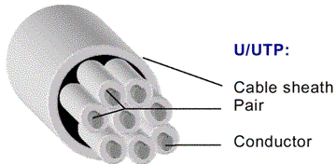
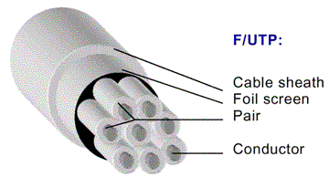
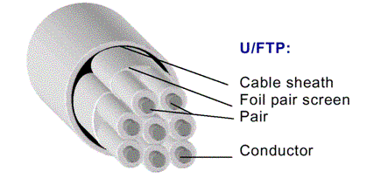
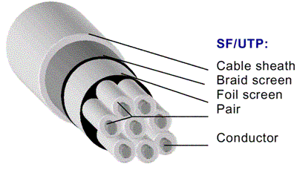
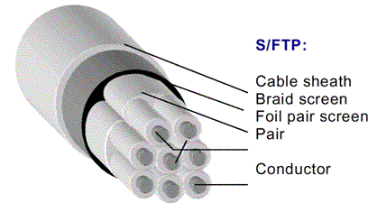
Note: Sometimes the letter P in the abbreviation is replaced by Q to characterize a quad construction.
U/UTP Quad
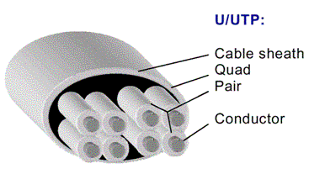
U/FTP Quad
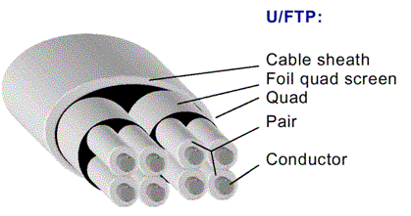
S/FTP Quad
